NZ Hanoverian Society –
AGM to be held at Huka Falls Lodge, Taupo

It’s that time of year again when we all get together and “talk horses” and to celebate the wonderful performances of Hanoverians and Rheinlanders over the past year - at the Annual General Meeting of your Society on Saturday 4th August 2018 at Huka Falls Lodge, Taupo

Lunch from 12:30pm and commence the Annual General Meeting at 4:00pm.

This year the format for the day will be as follows:

12 noon Doors open for Luncheon and gathering
12.30pm Luncheon served
Followed by a talk by Dr Leigh de Clifford BVSc. – Latest
Developments in the WFFS and OCD in foals and horses
2.00pm Awards presentation
4.00pm AGM Meeting commences - preceded by afternoon tea
7.00pm Move to Acacia Room for dinner (to be pre-paid on booking form)

Freephone 0800 485 284 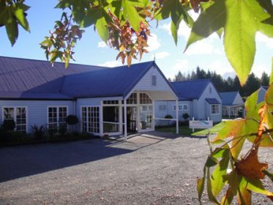
P.O. Box 155
56 Huka Falls Road,
Taupo 3351
New Zealand
T +64 7 376 0260
F +64 7 378 5333
info@hukafallsresort.com

